Defining “Capacity”

Policy and Program Goals (the “4 Cs”)

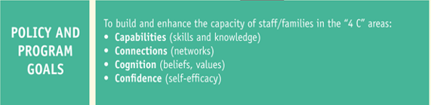

1. Capabilities
Families
- Families have increased their knowledge and understanding of what their children should know and be able to do from birth through secondary school and have increased their portfolio of tools and activities that they can use to enhance their children’s learning.
- Families have enhanced knowledge and understanding of educational policies and programs, such as those associated with special needs and Title I.
- Families have enhanced their own skills associated with literacy and language acquisition, degree completion, and job skills.

Staff
- District and school staff have increased their knowledge of the assets and funds of knowledge of the families and communities they work in.
- District and school staff have increased their knowledge and understanding of culturally responsive practices and pedagogy.
- District and school staff have increased their portfolio of ways to reach out and build respectful and trusting relationships with families.

2. Connections
- Levels of relational trust have increased between families and school staff.
- The number and scope of parent-to-parent networks and connections has increased.
- The number of cross-cultural networks (across race, socioeconomic status, education level, etc.) have increased between school staff and families.
- Families and staff have increased their connections to community agencies and services.

3. Confidence
- Families and school staff indicate an increase in their comfort level and sense of self-efficacy when engaging in home–school partnership events and activities.
- An increased number of families and staff from diverse backgrounds take on positions of leadership at the school or in the community.

4. Cognition
Families
- Families’ beliefs about the role they play in their children’s education have broadened to include multiple roles.
- Families’ belief systems about the value of home–school partnerships are linked to learning and school improvement.

Staff
- District and school staff members’ core beliefs about family engagement have been discussed and documented.
- Staff have a commitment to family engagement as a core strategy to improve teaching and learning.
- Staff belief systems about the value of home–school partnerships are linked to learning and school improvement.

