2020-2021
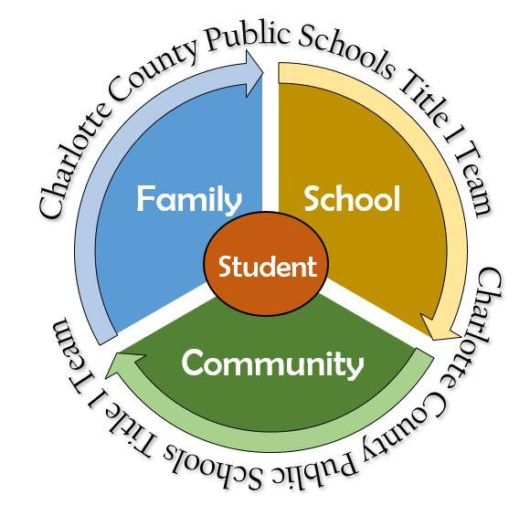
Title I - Parent & Family Engagement Planning Team (PFEPT) Members

School:

Name of PFEPT Member | Title/Role

NOTES/MINUTES
Documentation is required to show input from all stakeholders. REMEMBER to use the key below to denote input from stakeholders.
P= Parent/family
A= Administrator
T= Teacher and school staff
S= Student
C= Community member

