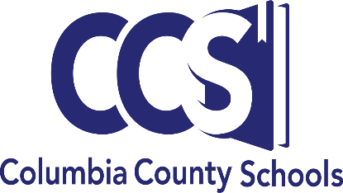
Office of the Superintendent
SUPERINTENDENT
ALEX L. CARSWELL, JR

ASSISTANT SUPERINTENDENTS
HOPE JERNIGAN
TODD WIDERGREN

MEMBERS OF THE BOARD
DANA BRADY-GIDDENS
STEPHANIE K. FINNELL
KEITH HUDSON
STEVE NELSON
NARRAGANSETT SMITH
372 West Duval Street
Lake City, Florida 32055-3990
(386) 755-8003
carswella@columbiak12.com
www.columbiak12.com

Agreement between Non-Public Schools and Columbia County School District for
Technology, Technology Devices, Equipment and Other Tangible Attractive Items

Name of School: Click or tap here to enter text.

The Columbia County School District retains ownership of any technology, devices, equipment and other tangible attractive items that are purchased through local, state and federal funds for use at Non-Public/Private Schools. These items will be placed in the inventory assessment management system of the Columbia County School District.

Non-Public/Private Schools are responsible for keeping these items in good working order. In the case in which items are destroyed, lost or stolen, the following procedures are to be followed by the respective Non-Public/Private School.

- Non-repairable or destroyed: The item is to be returned to the Columbia County School District using form CCSD 1169 DISPOSITION FORM along with a report of why or how the item was destroyed or non-repairable.

- Lost: Items that are lost are to be reported to the Columbia County School District as soon as it is discovered that the item is missing. Submit to the school district form CCSD 1169 DISPOSITION FORM along with a police report.

- Stolen: Items that are stolen are to be reported to the Columbia County School District as soon as it is discovered that the item was stolen. Submit to the school district form CCSD 1169 DISPOSITION FORM along with a police report.

It is agreed that the Columbia County School District retains ownership of any technology, devices, equipment and other tangible attractive items that are purchased through local, state and federal funds for use at Non-Public/Private Schools. Non-Public/Private Schools or personal representative may not sell, incentivize, give away, auction, file- insurance claims or receive funds in direct connection to purchased items.

_________________________________________ _________________________________________
Public School Official Date Private School Representative Date

Columbia County School District

_____________________________________ ___________________________________
School District Name of Private School Agency or School

