Title I Plan
G. Elementary
2021-2022

SUP Goals: Please enter your 2021-2022 Success Plan goals here. When completing the table below, use the goal number from this chart to reference which goal your plan items are related to.
- High Impact Instruction: Collaborative teams will provide well planned, rigorous lessons, aligned to the new BEST standards, to maximize staff and student engagement.
- Data Driven Decisions: The staff at Gulf Trace will use multi-tiered systems of support (MTSS) to collectively problem solve and plan for the support of all students.
- Collaborative Culture: We will create a culture of collective responsibility by increasing student, staff and family engagement.

20-21 NWEA Growth Data
Reading Observed Growth |  |  |  |  |  |  | Math Observed Growth |  |  |  |  |  |  | Science Observed Growth
K | 1 | 2 | 3 | 4 | 5 | Ave | K | 1 | 2 | 3 | 4 | 5 | Ave | 3 | 4 | 5 | Ave
12 | 12 | 9 | 3 | 7 | 8 | 8.5 | 13 | 13 | 9 | 11 | 13 | 12 | 11.8 | 3 | 6 | 8 | 5.67

20-21 FSA Proficiency Data
G3 ELA | G4 ELA | G5 ELA | Overall ELA | G3 Math | G4 Math | G5 Math | Overall Math | G5 Science
42 | 39 | 34 | 38 | 32 | 43 | 40 | 38 | 29

Activity / Initiative | SUP Goal # | Implementation Plan  (What is occurring? Who is implementing? How and when will it take place – including frequency?) | Baseline Data  (Data that is expected to improve because of this expenditure.) | Expected Results  (What is the expected result/goal for improvement?) | Monitoring  (Who is responsible? What tool and data will be used? How frequently will data be reviewed?) | Mid-Year ROI and Reflections  (Evidence of implementation, data and results, implications for future planning) | End of Year ROI and Reflections  (Evidence of implementation, data and results, implications for future planning)
AVID Field Trips | High Impact Instruction / Collaborative Culture / AVID Goal | AVID Field Trips College visitations 3-5, District academy visitations (K-5)  - AVID/Cambridge Leadership team will organize field trips both in the Fall and Spring. K-2 will have at least one field trip. 3-5 will have at least two field trips. | Overall Student Hope data is expected to increase on the Gallup. | By exposing scholars to colleges and the many options Pasco County Academies offer we will see an increase in Student Hope | Field trips will be organized by the Leadership team. The Cambridge Coordinator will have students complete a survey after the field trip to monitor Hope and Engagement. Data will be reviewed after each field trip. | Due to Covid restrictions – we were unable to go on these field trips. We did however decide to plan a College Day for February. | The success of College Day and the feedback was overwhelming so we will add that to our yearly calendar. Students were engaged and excited about college. We were able to hold several zoom meeting that focused on Careers and made connections to college requirements but we are looking forward to getting back to being able to incorporate field trips next year.
ELA ITC | High Impact Instruction / Data Driven Decisions | ITC - Jen Fernandez will continue working with PLCs on unpacking Florida’s new BEST Standards, best practices on the implementation of the new reading series as well as run coaching cycles with teachers to improve their overall craft.  - Jen will work weekly with teachers in PLCs as well as meet with individual teachers for one-on-one coaching. | We will see an increase in MAPs data over time. We will also see an increase in overall proficiency scores in our FSA ELA scores. | We will see a smooth transition with the implementation of both the new standards and reading series. We will also see an increase in overall FSA Reading scores. | Jen Fernandez will collect MAPS data 3x and look at HMH Module data. She will also compare FSA data at the end of the year. | We lost our ELA Coach at the beginning of the year and we were unable to fill the position until January. Teacher leaders stepped in and helped lead the work. | Once we hired a new coach we realized the gaps that were missing – we spent the rest of the spring getting a temperature check and starting at Step 0. We are proud of the work our teachers have accomplished but know that this summer the leadership team has a lot of planning to do around ELA to fill gaps and build a solid understanding of our new series and the BEST Standards.
Math ITC | High Impact Instruction / Data Driven Decisions | Math Coach – This position will work with teachers on planning rigorous TIER 1 lessons, they will use data to help create targeted TIER 2 and TIER 3 groups using Equip. They will also help teachers improve their craft by modeling high engaging lessons.  - The coach will work weekly with teachers in PLCs as well as meet with individual teachers for one-on-one coaching. | We will see an increase in MAPs data over time. We will also see an increase in overall proficiency scores in our FSA Math scores. | We will see an increase in overall math scores as well as FSA math learning gains. | Jen Steele will collect MAPS data 3x and look at Module data. She will also compare FSA data at the end of the year. | 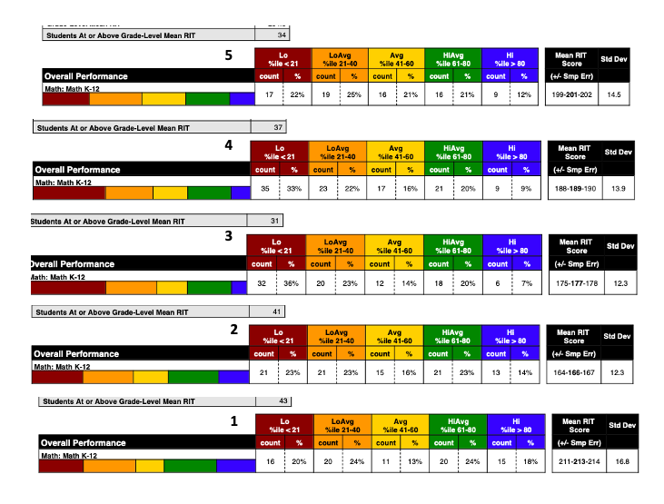  Coach met with PLCs and planned lessons and discussed data. | Math MAPs proficiency and growth was not as high as we would have liked. We will be looking at utilizing Zearn more next year as well as implementing Advance Math in grades 3 and 4.
Instructional Assistant | High Impact Instruction / Data Driven Decisions | Additional Instructional Assistant - David Benson will work with a specific grade level helping with Intervention Groups in all subject areas. | We will see an increase in 2nd grade ELA data. | We will see an increase in learning gains as strategically planned intervention groups are met with on a consistent basis. | Jen Fernandez our ELA coach will help plan intervention lessons and collect data. | We lost our ELA coach and the beginning of the year so she did not collect the data. But Mr. Benson worked with small groups on both ELA and math skills and also subbed when there were teacher shortages due to Covid absences. | Mr. Benson played a vital role to keeping our school afloat when times were tough due to the Covid Crisis. He subbed when needed and pulled and worked with groups on intervention skills.
SSAP | High Impact Instruction / Data Driven Decisions | SSAP - Coach Baker will continue to support our TIER 2 and TIER 3 Behaviors with check in - check outs, breaks and groups. He will also work with our behavior specialist and help train the staff in SEL strategies. | We will see a decrease in ODRs. | We will see a decrease in ODRs and teachers will also be better trained in SEL. | The SIT Team will monitor ODRs monthly. | Mid yearly the ODRs were at the same level as last year. We did notice that the majority of them were from Kindergarten and that 8% of the students were getting them. The PBIS team decided to put a celebration in place. | We ended the year with a higher number of ODRs but we saw a decrease towards the end due to our proactive strategies. We plan to have these in place when we start next year.  - Monthly incentives  - 5th Grade Leadership opportunities  - Goal Setting  - Class Meetings
PD for K-5 teachers | High Impact Instruction / Collaborative Culture | PD for K-5 teachers on the implementation of the new Best Standards and the new Reading series as well as Eureka Math.  - Coaching staff will create and deliver PD. | We will see an increase in MAPs data over time. We will also see an increase in overall proficiency scores in our FSA Math and ELA scores. | We will see an increase in both Reading and Math scores on the FSA. | Jen Fernandez and Jen Steele will collect MAPS data 3x and look at Module data for both ELA and Math. They will also compare FSA data at the end of the year. | At the mid-year we only had one coach and we were able to have math parent night. By the end of January, we were able to hire the rest of the coach team and at the time we quickly assessed what was the most pressing work needed that could be accomplished and make the biggest impact. | At the end of the year the new leadership team was able to come together an assess what was needed and prioritize – we will continue this work into next year.
Parent Involvement Coordinator | Collaborative Culture | Parent Involvement Coordinator - .5 position Sara Davis  - Sara will be responsible for Title 1 Crate and all documents that need to be submitted throughout the year. | Parent Surveys | We will see an increase in our Parent Surveys as we strengthen the home, school connection. | Sara Davis will meet with admin to check in monthly. | Mid-Year Title 1 crate was up to date. | End of Year Title 1 crate is up to date. We are looking at other ways to involve Sara Davis with Parent Involement.

